**MONYETLA BURSARY PROJECT**

**LIFE SCIENCES: PAST PAPER QUESTIONS - NERVOUS SYSTEM - 17/5/2025**

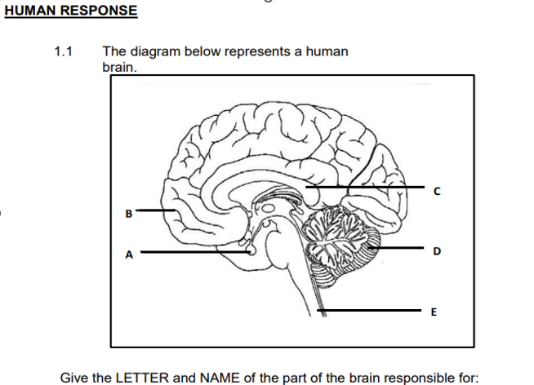

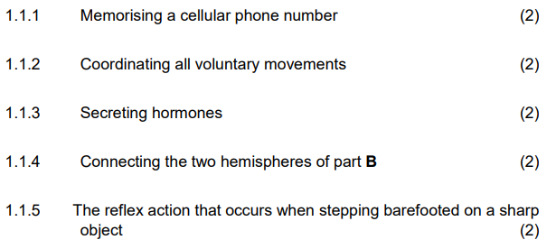

**Provide the correct terminology for each of the following:**

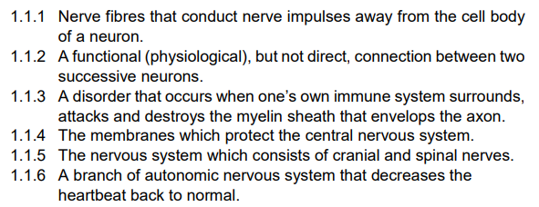

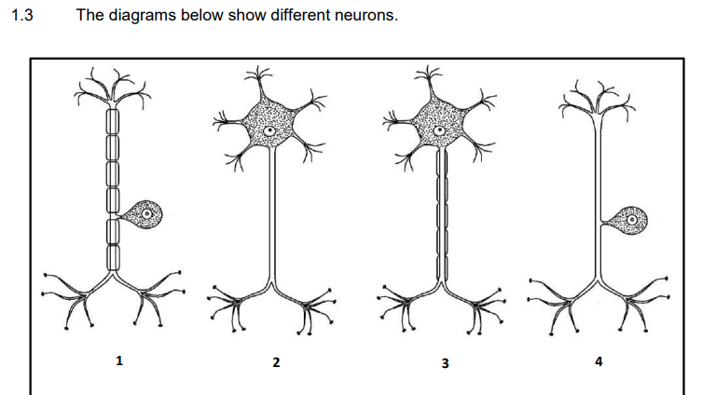

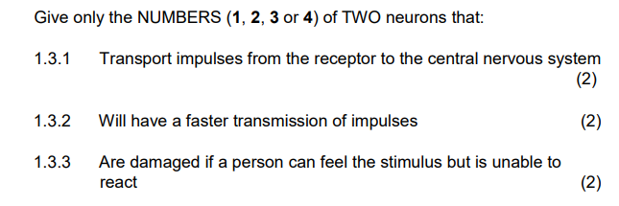

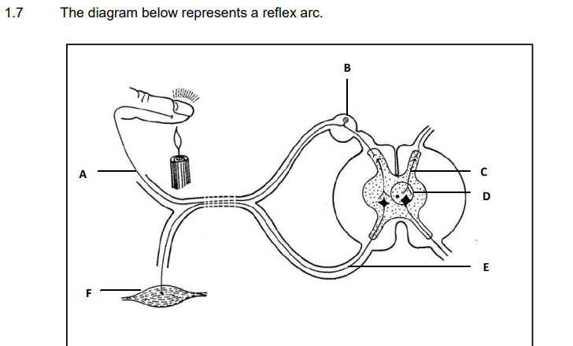

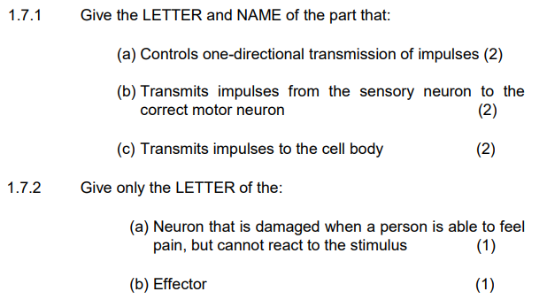

**ANSWERS**

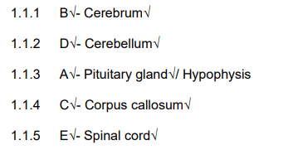**_____________________________**

**Terminology**

